

ASSET VERIFICATION AND RECORDING TOOL KIT


Plot 31, Bukoto Street
P.O Box 7657, Kampala, Uganda
+256 (0) 39 2000216/0772525235
email: cpa@cpa.ug

www.cpa.com

August to September 2026

VERIFICATION DETAILS

NAME OF THE REGION: | GREATER MASAKA
SUB-REGION:
Name of Local Government | KALUNGU DISTRICT
VERIFIER PARTICULARS
Full name | NANTUME PENNINAH/NASSALI VICTORIA K
Contact/ email and Telephone | 0760349649/0704321431
Supervisor/ Sub team leader
Name | KALYOWA LAWRENCE
Contact | 0774106047
Date of submission

HEALTH CENTRES
INFORMANT INTERVIEW/DISCUSSION GUIDE (INCHARGE OR RESPONSIBLE PERSON)

Name of Health Centre: KABAALE HEALTH CENTRE III

1a | Does the Facility have a record of all assets provided under UgIFT.  (Obtain a record and verify if it has the costs and numbers supplied | Yes
1b | If Not ask how many were supplied and when.

2 | How does this facility Maintain (repair/service/replace) the assets provided under Ugift

They receive funds

3 | Does the facility take regular record about functionality/ or breakdown of the assets provided? | Yes

4 | How has the UgIFT support helped in service delivery in the area, any issues, challenges and any recommendations for better program implementation.

Challenges
They are out dated in things they use
They don’t have enough staff
They lack profession in using these equipments

PROCEED TO VERIFICATION AFTER THIS DISCUSSION

Health centre checklist

NAME OF LG: KALUNGU DISTRICT LOCAL GOVERNMENT NAME OF HEALTH FACILITY: KABAALE HEALTH CENTRE III

Equipment/ Item | Department | Asset Number | Item  Description | Life in Months | Tag Number ( engrave no.) | Date Of Purchase | Date Placed In Service | Recoverable cost | Cost | Acc Dep Cost | Net Book Value | Ytd Deprn | Equipment status | Remarks
B.P. Machine, Digital | OPD |  | They were 2 white in colour |  | Not engraved | 4/6/2025 | 5/6/2025 |  |  |  |  |  | Good | Functional
B.P. Machine (Aneroid wall mounted) | MOH |  | They were 2 but not verified |  |  | 4/6/2025 | 5/6/2025 |  |  |  |  |  | Good | Functional
Autoclave 20 Liters.,Duo Operated
Bowl, Kick | MOH |  | It was 1 but not verified |  |  | 4/6/2025 | 5/6/2025 |  |  |  |  |  | Good | Functional
Bowl Stand | MOH |  | It was 1 but not verified |  |  | 4/6/2025 | 5/6/2025 |  |  |  |  |  | Good | Functional
Counting chamber Neubauer- Improved | MOH |  | They were 2 white in colour |  | Not engraved | 4/6/2025 | 5/6/2025 |  |  |  |  |  | Good | Functional
Cupboard Steel, Lockable | MOH |  | They were 2 white in colour |  | Not engraved | 4/6/2025 | 5/6/2025 |  |  |  |  |  | Good | Functional
Drip Stand | WARD |  | They were 8 silver steel on it with four wheels |  | Not engraved | 4/6/2025 | 5/6/2025 |  |  |  |  |  | Good | Functional
ESR Stand | MOH |  | It was 1 but not verified |  |  | 4/6/2025 | 5/6/2025 |  |  |  |  |  | Good | Functional
Examination Couch | MOH |  | They are 2 not verified |  |  | 4/6/2025 | 5/6/2025 |  |  |  |  |  | Good | Functional
Examination light,LED | MOH |  | They are 2 with bulbs |  | Not engraved | 4/6/2025 | 5/6/2025 |  |  |  |  |  | Good | Functional
Glucometer | MOH |  | They are 2 but not verified |  |  | 4/6/2025 | 5/6/2025 |  |  |  |  |  | Good | Functional
Haemoglobin Meter, Digital | MOH |  | They are 2 but not verified |  |  | 4/6/2025 | 5/6/2025 |  |  |  |  |  | Good | Functional
Height Meter | MOH |  | It is 1 white in colour |  | Not engraved | 4/6/2025 | 5/6/2025 |  |  |  |  |  | Good | Functional
Instrument Trolley | MOH |  | They are 2 silver in colour with 4 wheels black |  | Not engraved | 4/6/2025 | 5/6/2025 |  |  |  |  |  | Good | Functional
Microscope Binocular | LAB |  | It was 1 white in colour |  | Not engraved | 4/6/2025 | 5/6/2025 |  |  |  |  |  | Good | Functional
Otoscope | MOH |  | It was 1 but not verified |  |  | 4/6/2025 | 5/6/2025 |  |  |  |  |  | Good | Functional
Patient Screen | WARD |  | They are 4 blue cloth with silver stands |  | Not engraved | 4/6/2025 | 5/6/2025 |  |  |  |  |  | Good | Functional
Patient Trolley | OPD |  | It was 1 silver in colour and black wheels |  | Not engraved | 4/6/2025 | 5/6/2025 |  |  |  |  |  | Good | Functional
Refrigerator, Basic | MOH |  | It was 1 grey in colour with compartments |  | Not engraved | 4/6/2025 | 5/6/2025 |  |  |  |  |  | Good | Functional
Stethoscope | MOH |  | They are 4 but not verified |  |  | 4/6/2025 | 5/6/2025 |  |  |  |  |  | Good | Functional
Stop Watch | MOH |  | They are 2 but not seen |  |  | 4/6/2025 | 5/6/2025 |  |  |  |  |  | Good | Functional
Stretcher | MOH |  | It was 1 black mattress with a silver handle |  | Not engraved | 4/6/2025 | 5/6/2025 |  |  |  |  |  | Good | Functional
Stove, Gas | LAB |  | It is 1 white 6 kilos stabex |  | Not engraved | 4/6/2025 | 5/6/2025 |  |  |  |  |  | Good | Functional
Weighing Scale with Height Meter, Adult | MOH |  | They are 2 but not verified |  |  | 4/6/2025 | 5/6/2025 |  |  |  |  |  | Good | Functional
Weighing Scale, Infant | MOH |  | They are 2 but not verified |  |  | 4/6/2025 | 5/6/2025 |  |  |  |  |  | Good | Functional
Weighing Scale, Toddler | MOH |  | They are 2 but not verified |  |  | 4/6/2025 | 5/6/2025 |  |  |  |  |  | Good | Functional
Wheel Chair
Audio Visual Equipment
Medical Waste Bin | OPD |  | They are 6 steel and silver in colour |  | Not engraved | 4/6/2025 | 5/6/2025 |  |  |  |  |  | Good | Functional
Wall Clock | OPD |  | They are 4 white and brown |  | Not engraved | 4/6/2025 | 5/6/2025 |  |  |  |  |  | Good | Functional
Diagnostic Equipment Set for MCH | MOH |  | They are 2 but not seen |  |  | 4/6/2025 | 5/6/2025 |  |  |  |  |  | Good | Functional
Diagnostic Equipment Set for OPD | OPD |  | They are 2 but not seen |  |  | 4/6/2025 | 5/6/2025 |  |  |  |  |  | Good | Functional
Glassware Set, Laboratory, Basic | LAB |  | They are 2 glassless and breakable |  | Not engraved | 4/6/2025 | 5/6/2025 |  |  |  |  |  | Good | Functional
Hollow Ware Set, Treatment
Instrument Set, Dressing | MOH |  | They are 2 but not seen |  |  | 4/6/2025 | 5/6/2025 |  |  |  |  |  | Good | Functional
Instrument Set, Basic ENT | MOH |  | They are 3 but not verified |  |  | 4/6/2025 | 5/6/2025 |  |  |  |  |  | Good | Functional
Instrument Set, Suture
Pulse Oximeter, Hand held | MOH |  | They are 2 but not verified |  |  | 4/6/2025 | 5/6/2025 |  |  |  |  |  | Good | Functional
Bed, Adult Patient with Mattress | WARD |  | They are 10 black mattresses on it |  | Not engraved | 4/6/2025 | 5/6/2025 |  |  |  |  |  | Good | Functional
Bed, Pediatric Patient, With Mattress | WARD |  | They are 5 with black mattresses |  | Not engraved | 4/6/2025 | 5/6/2025 |  |  |  |  |  | Good | Functional
Bedside Locker
Cupboard, Instrument | OPD |  | It has 1 with 2 compartments in white colour. |  | Not engraved | 4/6/2025 | 5/6/2025 |  |  |  |  |  | Good | Functional
Delivery Bed, Hydraulic Manual | MOH |  | It is 1 with blue mattress |  | Not engraved | 4/6/2025 | 5/6/2025 |  |  |  |  |  | Good | Functional
Oxygen Therapy Apparatus, Mininum 45L cylinder | MOH |  | They are 2 but not seen |  |  | 4/6/2025 | 5/6/2025 |  |  |  |  |  | Good | Functional
Resuscitator Manual, Infant, with all Mask sizes | MOH |  | They are 2 but not seen |  |  | 4/6/2025 | 5/6/2025 |  |  |  |  |  | Good | Functional
Resuscitator Manual, Adult, with all mask sizes | MOH |  | They are 2 but not seen |  |  | 4/6/2025 | 5/6/2025 |  |  |  |  |  | Good | Functional
Suction Apparatus, (Electric) | MOH |  | They are 2 white in colour with bugs of water |  | Not engraved | 4/6/2025 | 5/6/2025 |  |  |  |  |  | Good | Functional
Nebulizer, Ultrasonic | MOH |  | It was 1 but not seen |  |  | 4/6/2025 | 5/6/2025 |  |  |  |  |  | Good | Functional
Oxygen Concentrator, Duo Flow | MOH |  | They are 4 with grey colour 2 handles on top |  | Not engraved | 4/6/2025 | 5/6/2025 |  |  |  |  |  | Good | Functional
Bench | OPD |  | They are 4 brown wooden |  | Not engraved | 4/6/2025 | 5/6/2025 |  |  |  |  |  | Good | Functional
Disinfection Buckets | OPD |  | They are 6 normal form with different colours |  | Not engraved | 4/6/2025 | 5/6/2025 |  |  |  |  |  | Good | Functional
Baby Cot | MOH |  | They are 5 silver color with rail |  | Not engraved | 4/6/2025 | 5/6/2025 |  |  |  |  |  | Good | Functional
Diagnostic Equipment Set for Ward | MOH |  | They are 3 but not seen |  |  | 4/6/2025 | 5/6/2025 |  |  |  |  |  | Good | Functional
Hollow Ware Set, Ward | MOH |  | They are 3 but not seen |  |  | 4/6/2025 | 5/6/2025 |  |  |  |  |  | Good | Functional
Instrument Set, Delivery | MOH |  | They are 3 but not seen |  |  | 4/6/2025 | 5/6/2025 |  |  |  |  |  | Good | Functional
Instrument Set, Stitch Removing | MOH |  | They are 3 but not |  |  | 4/6/2025 | 5/6/2025 |  |  |  |  |  | Good | Functional
MVA Kit | MOH |  | They are 4 but not very fine |  |  | 4/6/2025 | 5/6/2025 |  |  |  |  |  | Good | Functional
Stool, Laboratory | LAB |  | Its 1 black in color with 4 wheels |  | Not engraved | 4/6/2025 | 5/6/2025 |  |  |  |  |  | Good | Functional
Penguin Sucker | MOH |  | They are 3 rubber in nature |  | Not engraved | 4/6/2025 | 5/6/2025 |  |  |  |  |  | Good | Functional
Fetoscope, Dopplar | MOH |  | They are 2 silver in nature with a round top base |  | Not engraved | 4/6/2025 | 5/6/2025 |  |  |  |  |  | Good | Functional
Bubble CPAP
Centrifuge (Electric) | MOH |  | They are 2 but not seen |  |  | 4/6/2025 | 5/6/2025 |  |  |  |  |  | Good | Functional
Kangaroo Mother Care Chair | MOH |  | Its 1 with 4 wheels and soft sponge |  | Not engraved | 4/6/2025 | 5/6/2025 |  |  |  |  |  | Good | Functional
Radiant Infant Warmer
Haemoglobin Meter, Sahli
Delivery Bed
Examination light
Instrument set, ENT Basic for HCIII
Bag Valve mask (Ambu Bag), Neonatal
Incubator
Office Chair | OFFICE |  | They are 7 black swinging chairs |  | Not engraved | 4/6/2025 | 5/6/2025 |  |  |  |  |  | Good | Functional
Desk | OPD |  | They are 3 brown wooden desks |  | Not engraved | 4/6/2025 | 5/6/2025 |  |  |  |  |  | Good | Functional
Filing Cabinet
Non Residential Buildings
Residential Buildings |  |  | 1 block for health department |  |  | 4/6/2025 | 5/6/2025 |  |  |  |  |  | Good | Functional

Signpost Reception Drip stands
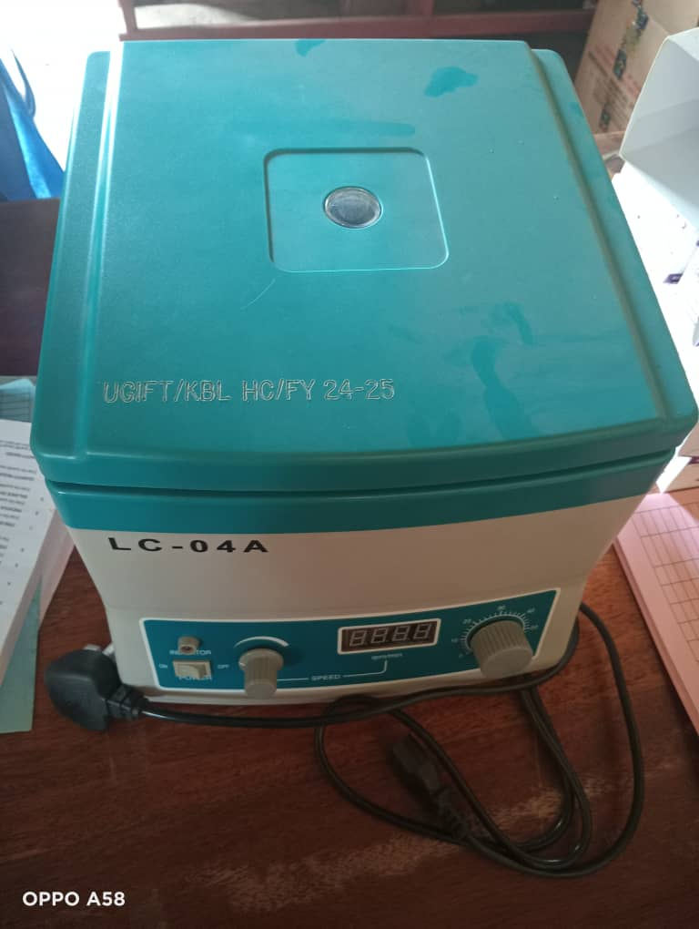
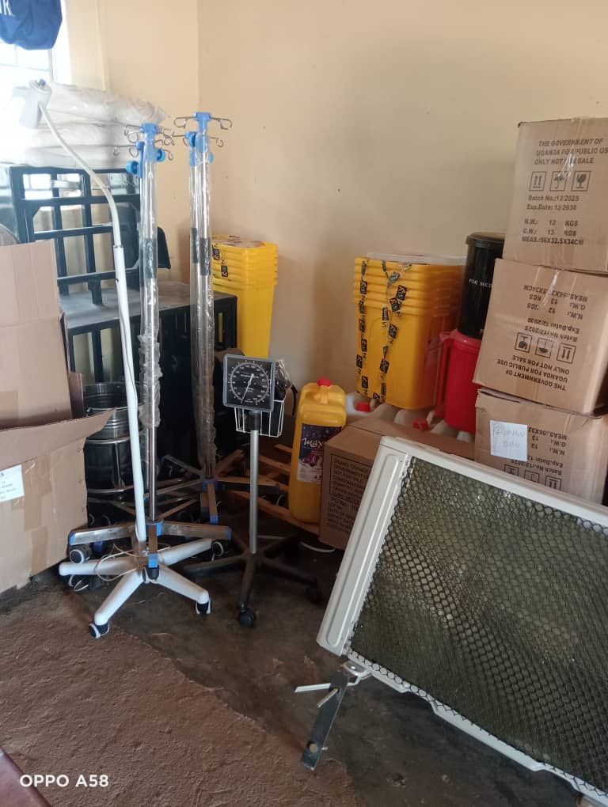
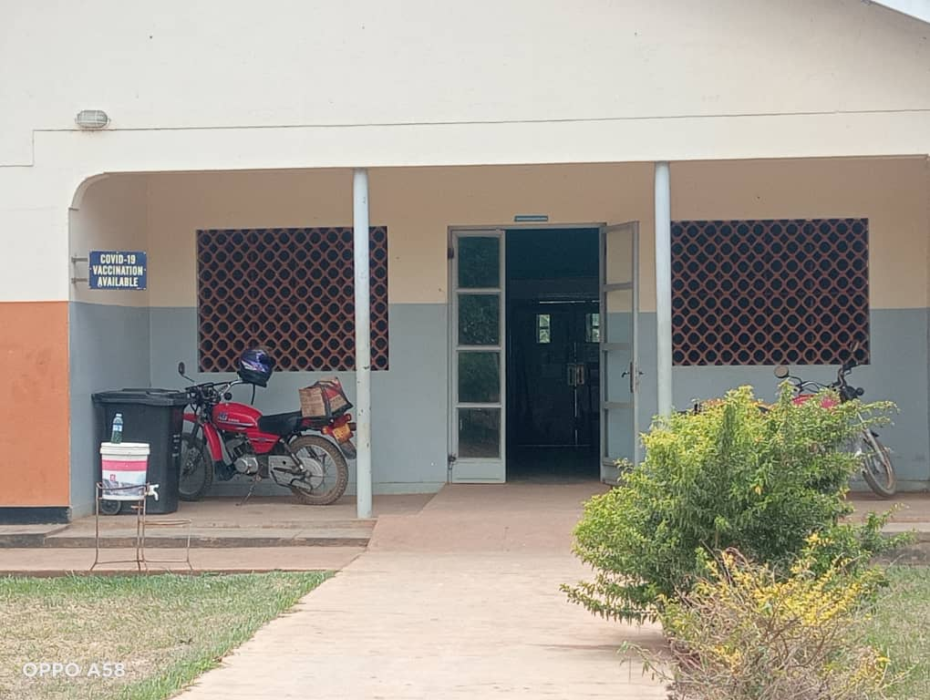

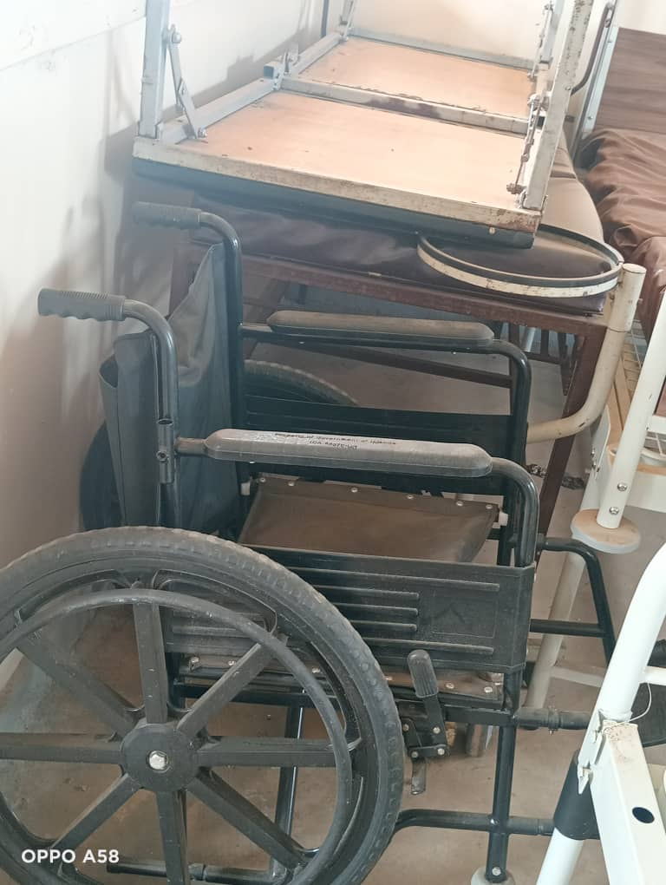
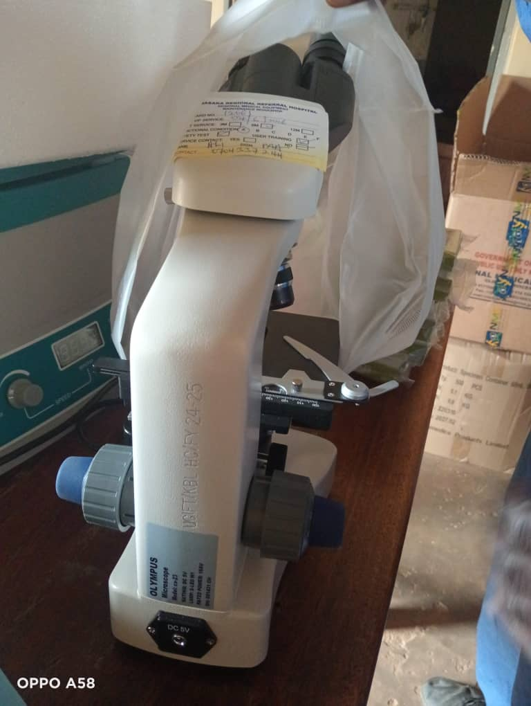

Microscope
Wheelchairs

SCHOOL VERIFICATION CHECKLIST

SCHOOL INTERVIEW/DISCUSSION GUIDE

Name of school: LUKAAYA SEED SECONDARY SCHOOL

1a | Does the Facility have a record of all assets provided under UgIFT.  (Obtain a record and verify if it has the costs and numbers supplied
1b | If Not ask how many were supplied and when.

2 | How does this facility Maintain (repair/service/replace) the assets provided under Ugift

3 | Does the facility take regular record about functionality/ or breakdown of the assets provided?  Nonfunctional/ working, and reasons for non-functionality.

4 | How has the UgIFT support helped in service delivery in the area, any issues, challenges and any recommendations for better program implementation.

PROCEED TO VERIFICATION AFTER THIS DISCUSSION

SCHOOL FURNITURE
(School Desks, Office chairs, Laboratory stools, Book shelves)

Name of LG: KALUNGU DISTRICT LOCAL GOVERNMENT Name of SCHOOL: LUKAAYA SEED SECONDARY SCHOOL

Equipment/ Item | Department | Asset Number | Item  Description | Life in Months | Tag Number ( engrave no.) | Date Of Pur | Date Placed In Service | Recoverable cost | Cost | Acc Dep Cost | Net Book Value | Ytd Deprn | Equipment status | Remarks
Desk | Education |  | Received 120 wooden desks |  | Not engraved |  |  |  |  |  |  |  | In use | functional
Tables | Education |  | They received 52 also wooden |  | Not engraved |  |  |  |  |  |  |  | In use | functional
Stools | Education |  | Thy received 92 wooden with black metallic stand |  | Not engraved |  |  |  |  |  |  |  | In use | functional
Office cabin | Education |  | They received 2 wooden with 2 compartments |  | Not engraved |  |  |  |  |  |  |  | In use | functional

ICT ITEMS TO VERIFY
(Desktop Computer, Server Processor, Network Switch 24 Port, Multipurpose Printer, UPS, Projector, Air Conditioners, Server, CCTV Camera)

Name of LG: KALUNGU DISTRICT LOCAL GOVERNMENT Name of SCHOOL: LUKAAYA SEED SECONDARY SCHOOL

Equipment/ Item | Department | Asset Number | Item  Description | Life in Months | Tag Number ( engrave no.) | Date Of Pur | Date Placed In Service | Recoverable cost | Cost | Acc Dep Cost | Net Book Value | Ytd Deprn | Equipment status | Remarks
Computers | Education |  | They  Received 28  Black in  Colour full  set |  | Not  engraved |  |  |  |  |  |  |  | Good | Functional
Printers | Education |  | It was 1  White in  colour |  | Not  engraved |  |  |  |  |  |  |  | Good | Functional
Projector | Education |  | It was 1  Black in  colour |  | Not  engraved |  |  |  |  |  |  |  | Good | Functional
CCTV | Education |  | It is 1 white  In colour |  | Not  engraved |  |  |  |  |  |  |  | Good | Functional
Gas cylinder | Education |  | They were 2  But not very  fine |  |  |  |  |  |  |  |  |  | Good | Functional

BUILDINGS TO VERIFY
(Non- Residential and Residential, Kitchen, Toilets/Pit latrine Water tanks, Fences etc.)

Name of LG KALUNGU DISTRICT LOCAL GOVERNMENT Name of SCHOOL: LUKAAYA SEED SECONDARY SCHOOL

Equipment/ Item | Department | Asset Number | Item  Description | Life in Months | Tag Number ( engrave no.) | Date Of Pur | Date Placed In Service | Recoverable cost | Cost | Acc Dep Cost | Net Book Value | Ytd Deprn | Equipment status | Remarks
Classroom blocks | Education |  | They received 3 blocks with 2 rooms each |  | Not  engraved |  |  |  |  |  |  |  | Good | Functional
Multipurpose hall | Education |  | Its 1 block for main hall |  | Not  engraved |  |  |  |  |  |  |  | Good | Functional
Library/ICT block | Education |  | Its 1 block shared by ICT and library |  | Not  engraved |  |  |  |  |  |  |  | Good | Functional
Science lab | Education |  | Its 1 block for science lab |  | Not  engraved |  |  |  |  |  |  |  | Good | Functional
Tanks | Education |  | Received 2 black tanks with different ltrs |  | Not  engraved |  |  |  |  |  |  |  | Good | Functional
Toilets | Education |  | 3 blocks with 5 rooms each |  | Not  engraved |  |  |  |  |  |  |  | Good | Functional
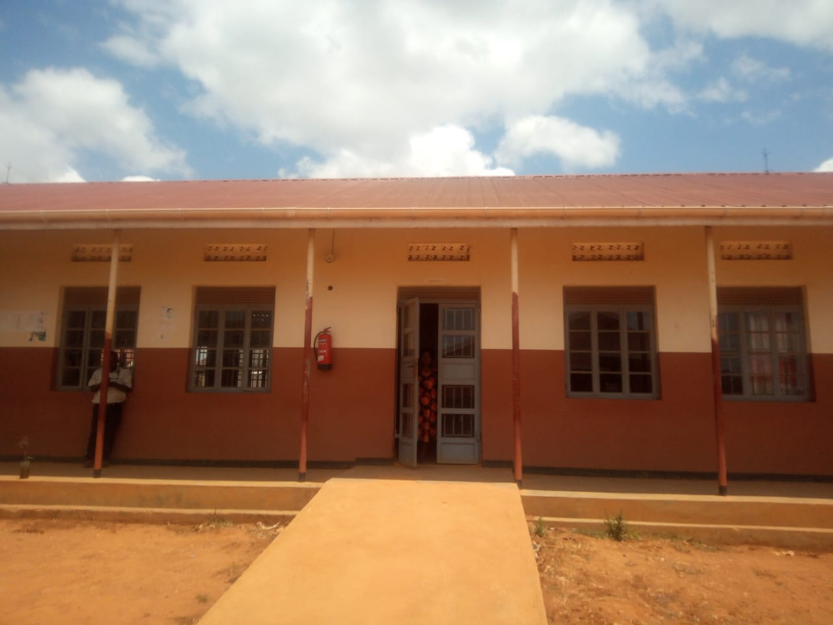
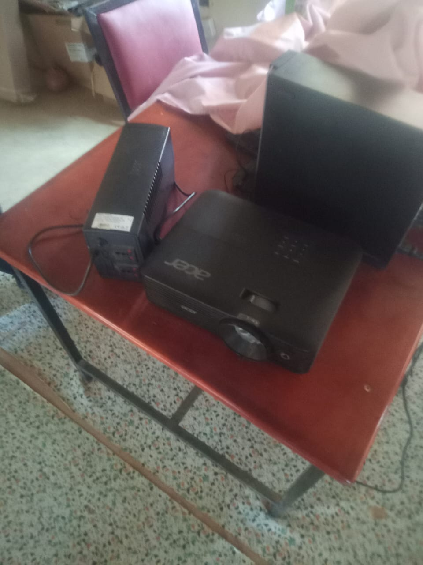
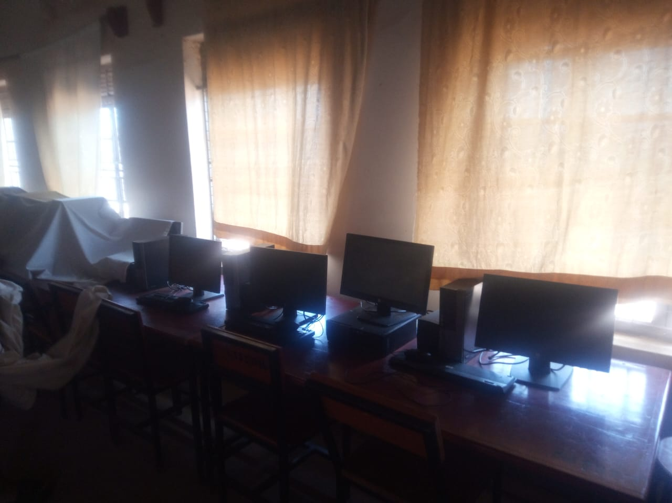
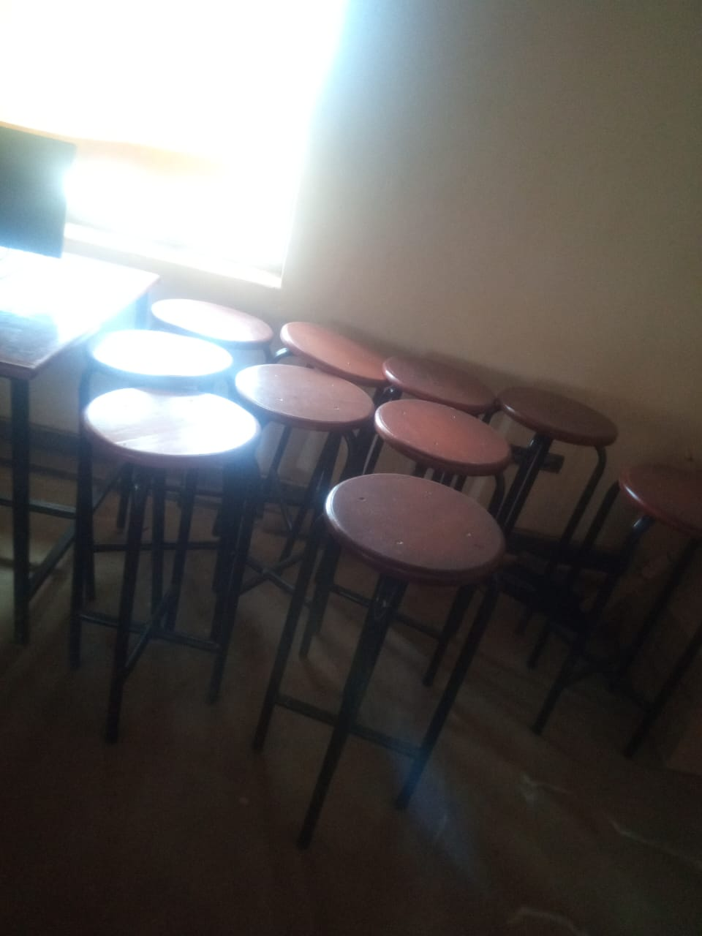

Desks Stools Computer lab Projector
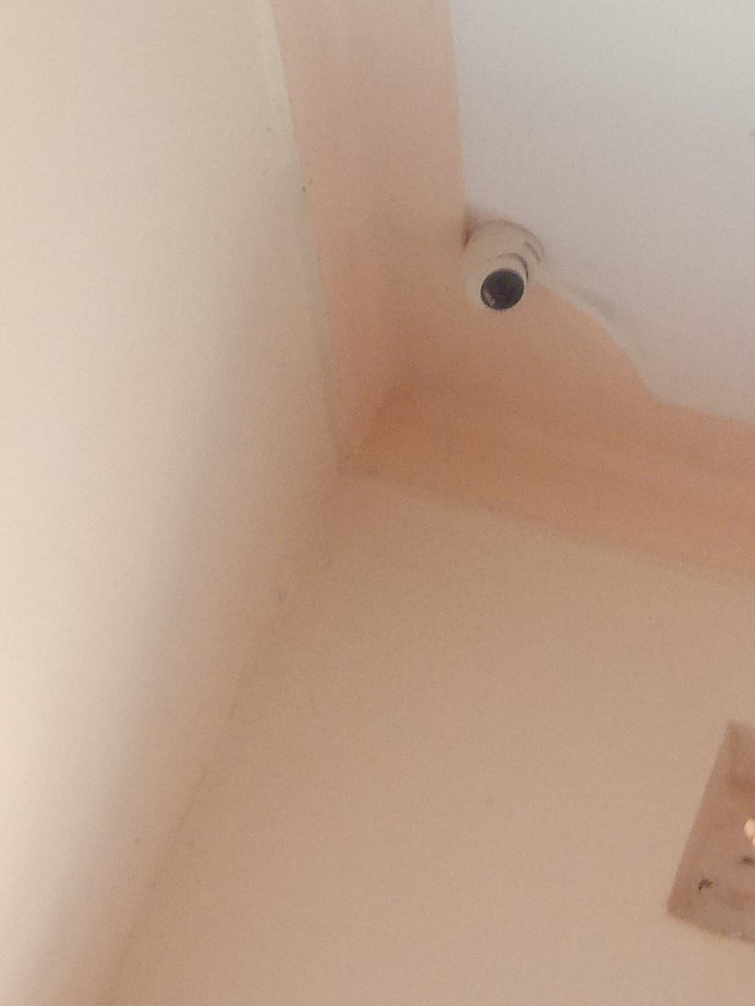
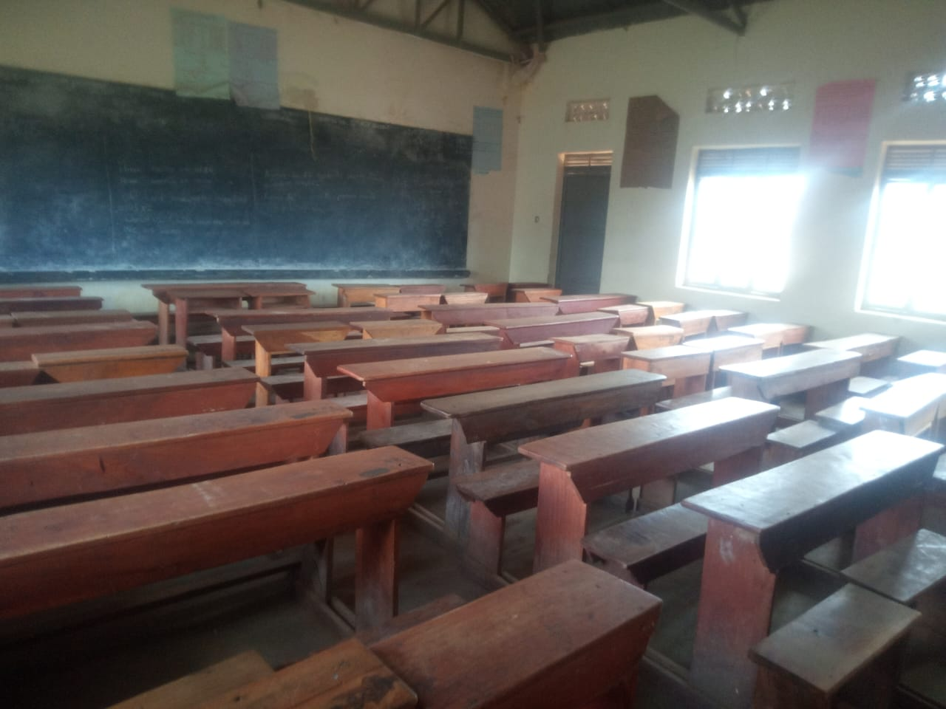

Camera
Administration block

